**MOCKITO EXERCISE**

Exercise 1: Mocking and Stubbing

Scenario:

You need to test a service that depends on an external API. Use Mockito to mock the

external API and stub its methods.

Steps:

1. Create a mock object for the external API.

2. Stub the methods to return predefined values.

3. Write a test case that uses the mock object.

**Class ExternalApi**

package com.example.Mockito;

public interface ExternalApi {

public String getData() ;

}

**Class MyService**

package com.example.Mockito;

public class MyService {

ExternalApi mockApi;

public MyService(ExternalApi mockApi) {

this.mockApi=mockApi;

}

public String fetchData() {

// **TODO** Auto-generated method stub

return mockApi.getData();

}

}

**Class MyServiceTest**

import static org.mockito.Mockito.*;

import org.junit.jupiter.api.Test;

import org.mockito.Mockito;

public class MyServiceTest

{

@Test

public void testExternalApi() {

ExternalApi mockApi = Mockito.mock(ExternalApi.class);

when(mockApi.getData()).thenReturn("Mock Data");

MyService service = new MyService(mockApi);

String result = service.fetchData();

assertEquals("Mock Data", result);

}

}

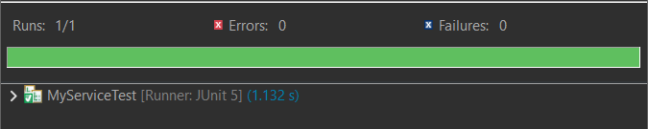

Exercise 2: Verifying Interactions

Scenario:

You need to ensure that a method is called with specific arguments.

Steps:

1. Create a mock object.

2. Call the method with specific arguments.

3. Verify the interaction.

**Class ExternalApi**

package com.example.Mockito;

public interface ExternalApi {

public String getData() ;

}

**Class MyService**

package com.example.Mockito;

public class MyService {

ExternalApi mockApi;

public MyService(ExternalApi mockApi) {

this.mockApi=mockApi;

}

public String fetchData() {

// **TODO** Auto-generated method stub

return mockApi.getData();

}

}

**Class MyServiceTest**

package com.example.Mockito;

import static org.junit.Assert.*assertEquals*;

import static org.mockito.Mockito.*;

import org.junit.jupiter.api.Test;

import org.mockito.Mockito;

public class MyServiceTest

{

*@Test*

public void testVerifyInteraction() {

ExternalApi mockApi = Mockito.*mock*(ExternalApi.class);

*when*(mockApi.getData()).thenReturn("Mock Data");

MyService service = new MyService(mockApi);

service.fetchData();

*verify*(mockApi).getData();

}

}

